ATLAS focuses on the standardization of
interfaces in knowledge-based farming
In the "Agricultural Interoperability and Analysis System (ATLAS)" project leading manufacturers of agricultural technology are working together with associations, companies as well as universities and research institutions to standardize data interfaces in the field of cloud-based agricultural applications. The project is scheduled for three years and is funded by the EU's H2020 research programme.
Among the 30 project partners the Agricultural Industry Electronics Foundation (AEF) are participating and as such representing the interests of the leading machine manufacturers. The Fraunhofer IAIS is supporting and coordinating the project as research partner. Stefan Rilling is the responsible coordinator on the Fraunhofer IAIS side. The aim is to establish an open digital service platform for agricultural applications with positive effects for a sustainable digital ecosystem, in which many industry players contribute their expertise and innovation towards added value in this new world of data-driven agriculture.

The data belongs to the farmer
The farmer, with his tasks and requirements, is at the centre of ATLAS' developments: It is his decision as to which sensors, machines and services are to be used and his decision as to which data he wants to share with whom. Although there are already numerous technical solutions and services for data-driven agriculture, lack of data links between the clouds of different manufacturers or closed solutions of individual manufacturers impede an optimal work process on the farm. The choice of machines, sensors and data processing platforms is limited, so is the flexibility to adapt these systems to the specific needs of individual farmers. The exchange of data and the ability to derive valuable knowledge from combining all these different data sources does not take place at all, or only takes place to a limited extent.
ATLAS will solve these problems through an open service platform that enables connectivity of sensors and machines, allowing the unrestricted combination of agricultural machinery, sensor systems and data analysis tools – in line with the optimum process on the farm. This will enable farmers in future to use the most advanced digital technologies and data to make knowledge based decisions to increase their productivity in a sustainable way.

Collaboration for the benefit of the entire industry
The ATLAS project brings together actors along the digital agricultural value chain at regional and European level. The standardization of interfaces between data clouds from manufacturers is a logical continuation of previous developments. It ties in with the basic ideas of the AEF on the uniqueness of the ISOBUS standard as well as with previous projects and initiatives of other project partners. Everyone involved agrees that the standardization process is important in order to realize its benefits for agricultural users as quickly as possible.

Number of characters of the article: 3,010 with blanks

The Agricultural Industry Electronics Foundation (AEF)
The Agricultural Industry Electronics Foundation (AEF) is an independent organization founded on October 28th 2008 by seven international ag equipment manufacturers and two associations. Today eight manufacturers and three associations are working as core members together with 220 general members. They work to improve cross-manufacturer compatibility of electronic and electric components in agricultural equipment, and to establish transparency about compatibility issues. Implementing international electronic standards is therefore a cornerstone of our work. Furthermore the AEF encourages the development and implementation of new technology. While the AEF’s intention is to enable mutually beneficial links between companies, the effort is first and foremost directed at their farming customers, i.e. to make work easier for them and to provide them with economic benefits.

Picture caption (AEF_ATLAS_EN_PRINT.pdf)
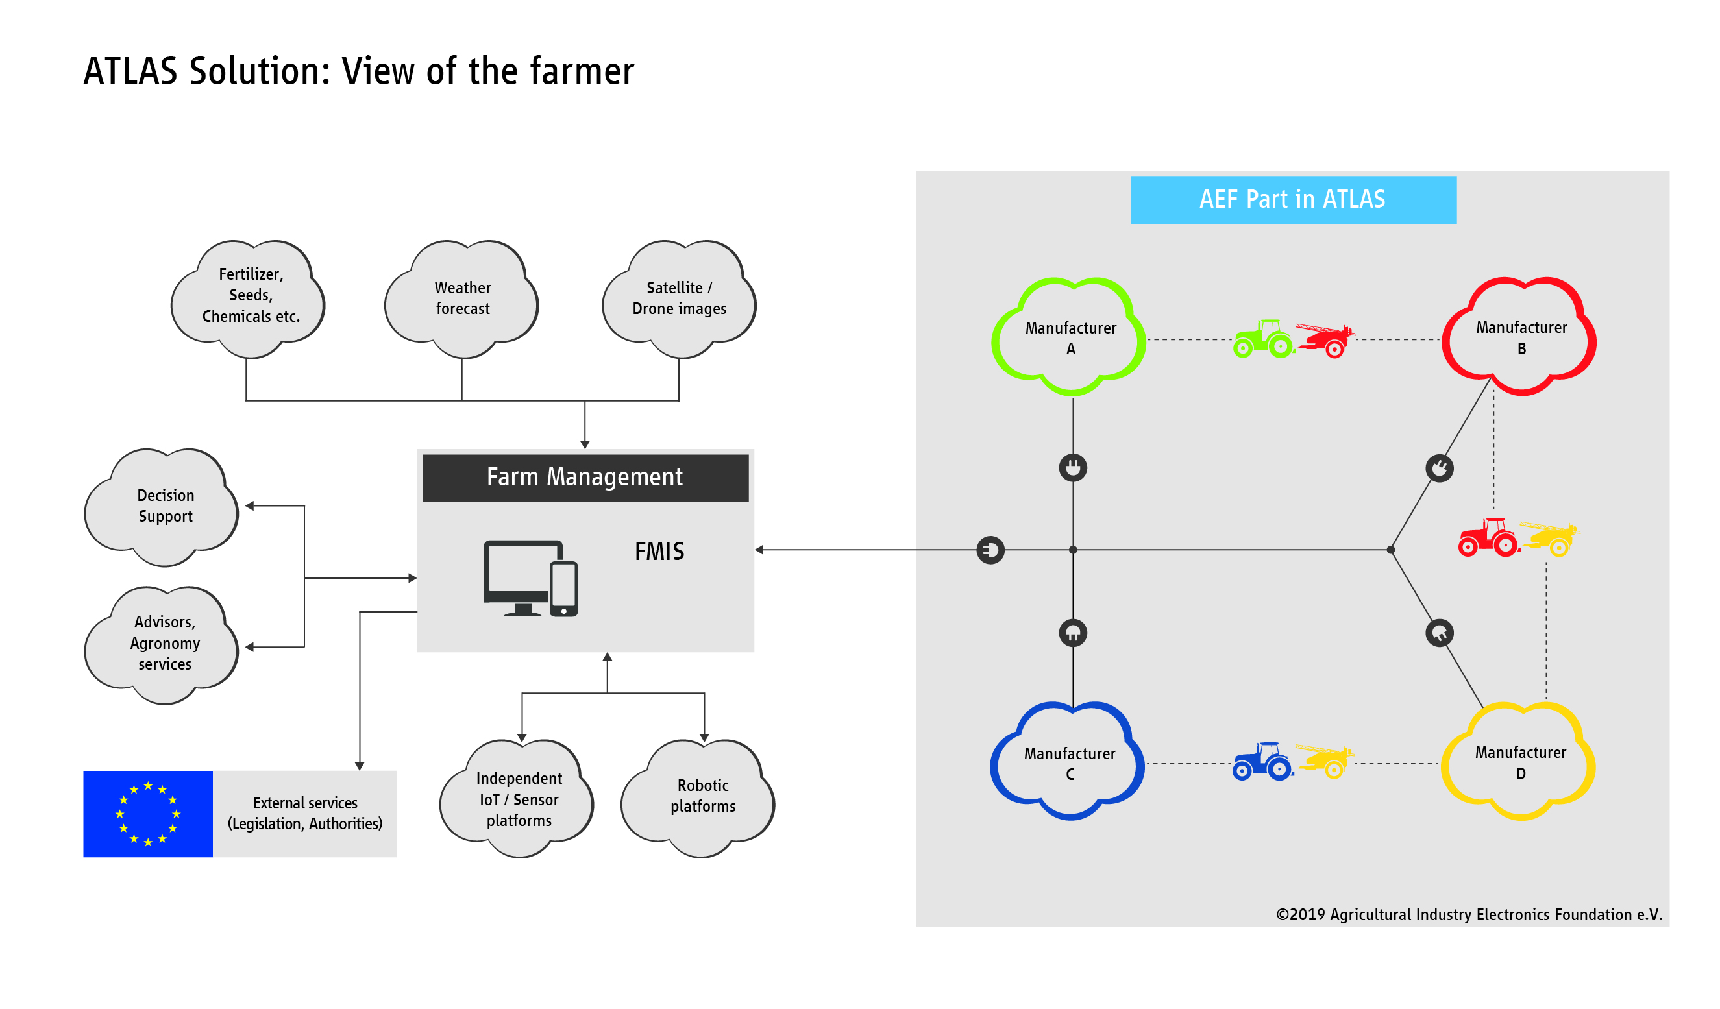
The farmer, with his tasks and requirements, is at the centre of ATLAS' developments.

Image source
Please indicate as image source: Agricultural Industry Electronics Foundation e.V.
The reprint is free of charge. We would be very pleased to receive a specimen copy.

Download press releases and images
www.aef-online.org/news/press-releases/

Press Contact
Agricultural Industry Electronics Foundation e.V.
AEF Office, Klaudia Lach
Blessenstätte 36 | 33330 Gütersloh
Phone +49 (0) 5241 30 57 908 | Mobile +49 (0) 151 72 10 75 23
office@aef-online.org | www.aef-online.org

