Further development of the AEF ISOBUS Database
Which implement can be operated with the tractor’s ISOBUS terminal? Which functionalities are supported by the combination of vehicles? Can the farmer continue to use his existing terminal when buying a new tractor? And what about the joystick? Answers to these questions can be obtained from the AEF ISOBUS Database which has been further developed in time for Agritechnica 2019. Access to the database is available for manufacturers, dealers and the public.

AEF Compatibility Check – Improved User Interface and even more information
The AEF ISOBUS Database allows users to learn about ISOBUS functionalities supported by both the single product and several selected products. This gives the user an overview of which functionalities are available for the selected combination. A new, more attractive and cleaner look has been given to the graphical interface, but in addition, even more detailed information is available to the user as required. With a sprayer, for example, the database shows whether it supports part-width section control and how many nozzles are available. On a tractor with a certified job computer (TECU), the user receives information on speed and PTO shaft speed.

Dealer registration and AEF ticket system
The dealer registration is also new. Now dealers will be able to register and log into the AEF ISOBUS Database themselves. This enables them to check which ISOBUS functionalities are supported on the products that they are working with. When registering, the dealer also selects the manufacturer brands he cooperates with. After confirmation by the manufacturer(s), he can contact the manufacturer with a service ticket if he has questions about the compatibility of ISOBUS products or problems in the field. He can also download the AEF ISOBUS CheckTool free of charge. This diagnostic tool collects information from all electronic control units on the ISO bus, including ECU manufacturer name, product name and version numbers of software and hardware.

Manufacturers: Carry out AEF Conformance Test yourselves
The AEF is also working on an improvement that will allow manufacturers to carry out the Conformance Test themselves by following a defined set of AEF Rules in order to ensure continued reliability for their customers. The AEF Conformance Test can be performed by the manufacturers themselves if the hardware has already been tested. In addition, the software certification of the product – carried out by one of the five independent AEF test institutes – must not be more than two years old. It is also important that the corresponding part of ISO11783 and the functionality of the software remain unaffected. The AEF test institutes are responsible for the final acceptance and approval of the repeated test.

Service Council to be continued
The enhancements described are the result and experience of the AEF project teams and the first AEF Service Council which took place at the end of 2018. In the course of the event, the participants formulated corresponding requirements based on their practical experience with the Database. The AEF plans to continue the Service Council on 30 October at DEULA Westfalen-Lippe GmbH in Warendorf. Once again, the event is aimed at employees from service and product management departments of dealers and manufacturers and the findings will be used to make further enhancements to the AEF ISOBUS Database.
Further information on the AEF and the AEF ISOBUS Database can be found at www.aef-online.org.

Number of characters of the article: 3,523 with blanks

The Agricultural Industry Electronics Foundation (AEF)
The Agricultural Industry Electronics Foundation (AEF) is an independent organization founded on October 28th 2008 by seven international ag equipment manufacturers and two associations. Today eight manufacturers and three associations are working as core members together with 220 general members. They work to improve cross-manufacturer compatibility of electronic and electric components in agricultural equipment, and to establish transparency about compatibility issues. Implementing international electronic standards is therefore a cornerstone of our work. Furthermore the AEF encourages the development and implementation of new technology. While the AEF’s intention is to enable mutually beneficial links between companies, the effort is first and foremost directed at their farming customers, i.e. to make work easier for them and to provide them with economic benefits.

Picture caption (AEF_Database_2019.png)
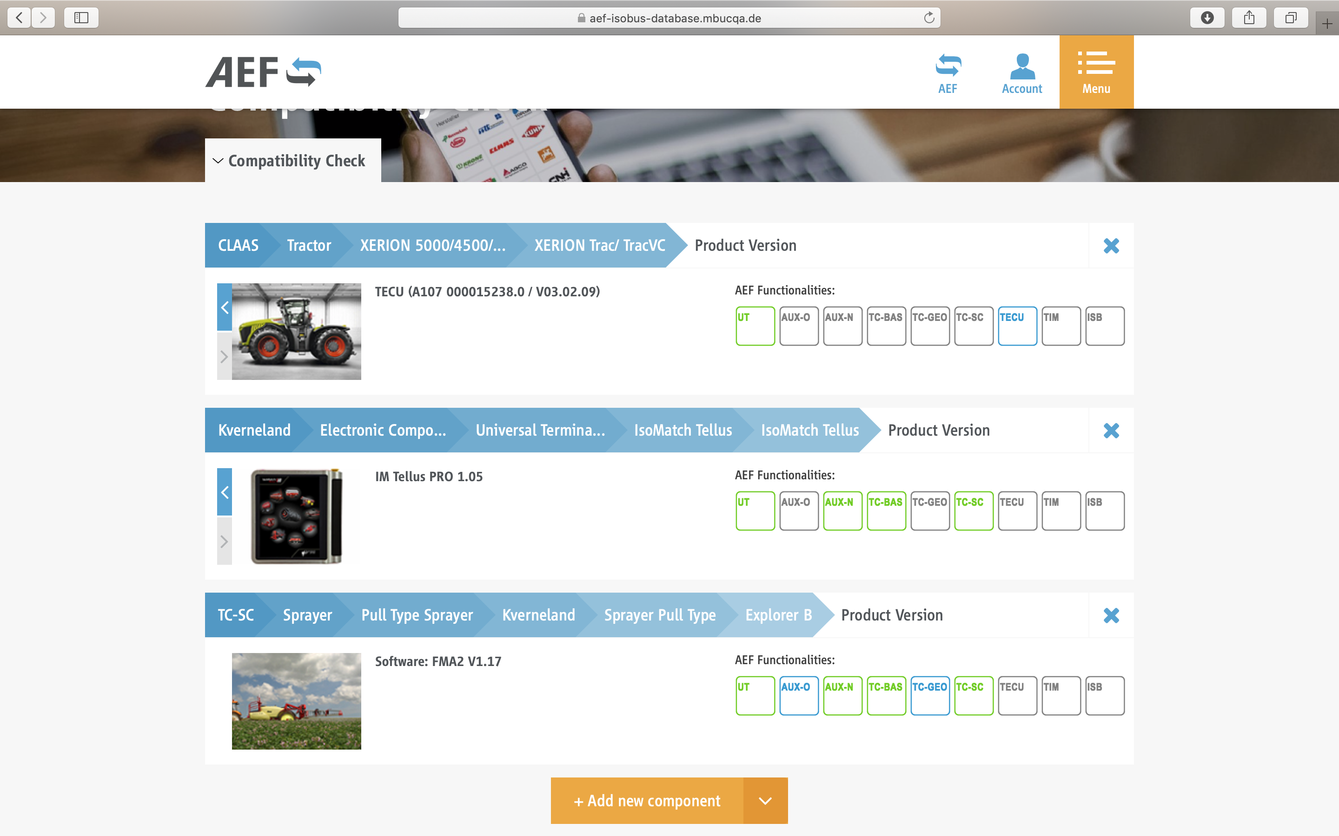
The AEF ISOBUS Database in a new, more attractive and cleaner look.

Image source
Please indicate as image source: Agricultural Industry Electronics Foundation e.V.
The reprint is free of charge. We would be very pleased to receive a specimen copy.

Download press releases and images
www.aef-online.org/news/press-releases/

Press Contact
Agricultural Industry Electronics Foundation e.V.
AEF Office, Klaudia Lach
Blessenstätte 36 | 33330 Gütersloh
Phone +49 (0) 5241 30 57 908 | Mobile +49 (0) 151 72 10 75 23
office@aef-online.org | www.aef-online.org

