TIM – secure industry leading communication
between tractor and implement
The AEF is pleased to be a recipient of an AE50 award of the American Society of Agricultural and Biological Engineers (ASABE) for 2020 for the development of the Tractor Implement Management (TIM) functionality. For the first time this system enables secure, industry leading communication between tractors and implements from different manufacturers. TIM is a cross-product and cross-manufacturer ISOBUS solution where the implement controls certain tractor functions and optimizes the working process. What is new is that the implement sends information to the tractor via standardized and secure communication which leads to an optimization of the overall system.

Standardized solution with digital certificates
Up until now, in most ISOBUS solutions the tractor controls the implement, however TIM is based on bidirectional communication, in other words, allowing the implement to play the leading role with ISOBUS as the basis for this communication.
The implement is only able to play the leading role if the data transmission is secure. For this purpose, the AEF has developed an infrastructure that enables secure communication based on proven standards, such as electronic banking. This standardized solution – in conjunction with digital certificates – is necessary so that the implement can control certain tractor functions and can actively carry out the work process without driver input. Both tractor and implement trust each other so that the farmer can work more efficiently.

Significant further development by the AEF
At Agritechnica 2009, ISOBUS Class 3 solutions – where machines of the same manufacturer exchanged data – were presented but there was no secure communication. In the following years, individual agricultural machinery manufacturers tested this technology in various machines until it was ready for the market. The basic idea was: The implement controls tractor functions such as forward speed or control valves to relieve the driver and to increase machine performance and productivity. However, there was a restriction that a machine combination from different manufacturers was not possible.
The AEF has taken up the basic idea of the ISOBUS Class 3 solution and made decisive progress with a new infrastructure for secure communication. This standardized solution with digital certificates is the only way to ensure manufacturer-independent cooperation between tractors and implements in terms of maximum brand flexibility.

How does it work technically speaking?
In order to obtain AEF certification, ISOBUS devices have to pass the AEF Conformance Test which tests for compatibility according to the ISOBUS standard and the AEF guidelines. Moreover, the product must meet “state of the art” safety standards. As soon as the Conformance Test has been successfully completed, the AEF supplies a “digital certificate”, which will be integrated in the tested TIM machine. With the first connection between the tractor and implement combination, the machines check the validity of their digital certificates. If in agreement, the tractor and implement exchange a shared key. This key will be checked when starting the tractor/implement combination and if the result is positive, the farmer will be able to use TIM. Only then, the implement will automatically control the tractor without intervention from the driver.
Advantages for the farmer
TIM makes optimum use of the installed performance potential for higher productivity of the overall system. Automatic processes replace manual operation and prevent the driver trying to exceed the system capabilities.
With TIM, the farmer works more precisely, effectively and economically while simultaneously increasing quality. TIM saves time and money. The field operation becomes technically simpler and easier as TIM takes over tiring and repetitive tasks. And: the farmer can use TIM with his tractors and implements from different manufacturers.

Pioneering role in agricultural engineering
Secure communication is of fundamental importance for digitized agriculture. Here, agricultural technology must take on a pioneering role with a manufacturer-independent application. The standardized solution with digital certificates fulfils this condition and thus offers potential for further applications, such as wireless in-field communication. This solution forms the basis for future-oriented developments in the entire field of agricultural engineering.
Interested parties can obtain detailed information about the new TIM functionality at the AEF booth in hall 15, H43. Starting in December 2019, manufacturers can have their TIM products certified by the AEF ISOBUS Conformance Test.
Further information on the AEF, TIM and the AEF ISOBUS Database can be found at www.aef-online.org.

Number of characters of the article: 4,834 with blanks

The Agricultural Industry Electronics Foundation (AEF)
The Agricultural Industry Electronics Foundation (AEF) is an independent organization founded on October 28th 2008 by seven international ag equipment manufacturers and two associations. Today eight manufacturers and three associations are working as core members together with 220 general members. They work to improve cross-manufacturer compatibility of electronic and electric components in agricultural equipment, and to establish transparency about compatibility issues. Implementing international electronic standards is therefore a cornerstone of our work. Furthermore the AEF encourages the development and implementation of new technology. While the AEF’s intention is to enable mutually beneficial links between companies, the effort is first and foremost directed at their farming customers, i.e. to make work easier for them and to provide them with economic benefits.

Picture caption (AE50_TIM_Logo.jpg)

The official logo of the AE50 award for 2020.

Picture caption (AEF_TIM_EN_PRINT.pdf)
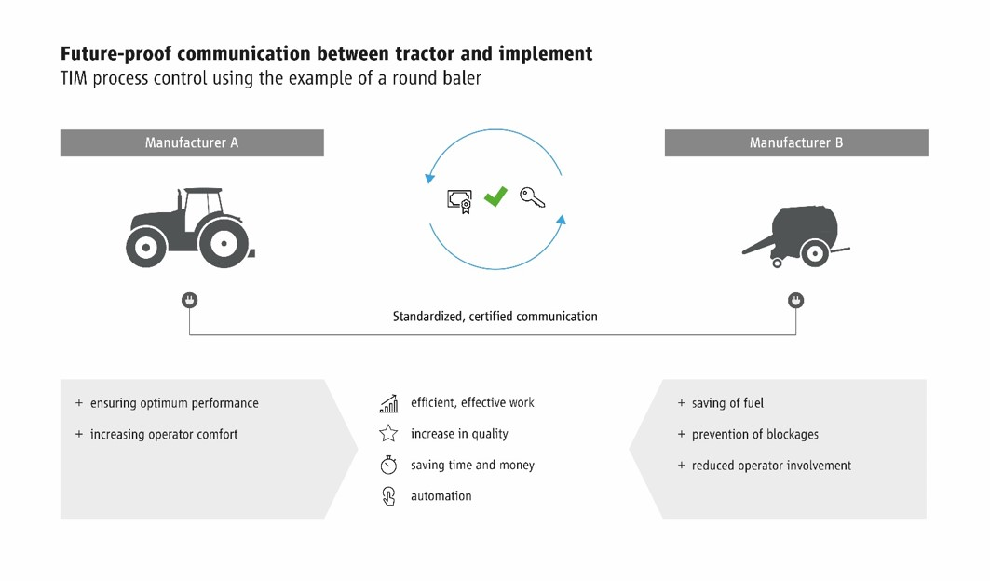
The standardized solution of TIM with digital certificates is the only way to ensure manufacturer-independent cooperation between tractors and implements in terms
of maximum brand flexibility.

Image source
Please indicate as image source: Agricultural Industry Electronics Foundation e.V.
The reprint is free of charge. We would be very pleased to receive a specimen copy.

Download press releases and images
www.aef-online.org/news/press-releases/

Press Contact
Agricultural Industry Electronics Foundation e.V.
AEF Office, Klaudia Lach
Blessenstätte 36 | 33330 Gütersloh
Phone +49 (0) 5241 30 57 908 | Mobile +49 (0) 151 72 10 75 23
office@aef-online.org | www.aef-online.org

