AEF TO SHOWCASE INDUSTRY TECH COLLABORATIONS AT AGRITECHNICA
Receives Two Industry Award Nominations for Impactful Solutions
The Agricultural Industry Electronics Foundation (AEF), a global non-profit organization founded to improve cross-manufacturer compatibility in agricultural equipment, will exhibit at AGRITECHNICA, the world’s leading trade fair for agricultural machinery, 12 – 18 November in Hanover, Germany. AEF will showcase a variety of crucial technologies that are being developed through cross-industry collaborations in order to benefit farmers throughout the world.
“AGRITECHNICA provides an excellent platform to show attendees how the agricultural industry is collaborating together to develop real solutions for the farmer,” said Norbert Schlingmann, General Manager, AEF. “Through these collaborations, the leap over the digital divide will finally be possible.”
The AEF, originally formed in 2008 to resolve farmers’ equipment incompatibility issues and to increase the overall understanding of ISOBUS, will highlight a variety of future tech solutions, including:
The Agricultural Interoperability Network (AgIN):
At AGRITECHNICA, the AEF will introduce AgIN, a network that will provide the framework to foster collaboration between agricultural industry members, partners and related initiatives. AgIN will enable peer-to-peer cloud connections, creating a milestone industry-wide solution to share data for those agreed to interoperability.
The Agricultural Interoperability Network has been selected on the shortlist for the DLG-Agrifuture Concept Winner 2023, for pioneering agricultural machinery work and future visions.

Universal Terminal Third Generation (UT3) Conformance Test:
The new standardized test will help manufacturers identify and reduce compatibility issues, guaranteeing even more cross-brand interoperability between ISOBUS certified devices.
High Speed ISOBUS (HSI):
With greater bandwidth and faster connection speed, roughly 4,000 times faster than ISOBUS, HSI will open new opportunities for innovation and serve the industry far into the future as even more performance and automation is demanded.
Wireless Infield Communication (WIC):
Nominated for the Systems & Components Trophy – Engineers’ Choice 2023, WIC will allow machines from different manufacturers working in the same field, or on the same operation, to communicate wirelessly. WIC will enable: Coverage map sharing between machines of different colours, camera (on one machine) and remote display (on another machine), even platooning (one machine controlling another) will be possible. In addition, this type of communication is important for road safety and can be used to communicate to road users (cars and trucks) when there is an ag machine entering the road.
Winners of the AGRITECHNICA Systems & Components Trophy – Engineers’ Choice 2023, and the DLG-Agrifuture Concept award will be announced in mid-October.
Attendees may visit the AEF at AGRITECHNICA in Hall 8, stand D15. To learn more information about the AEF, please visit www.aef-online.org

The Agricultural Industry Electronics Foundation (AEF)
The Agricultural Industry Electronics Foundation (AEF) is an independent organization founded in 2008. Eight agriculture equipment manufacturers and three associations are working as core members together with over 280 general members to improve cross-manufacturer compatibility of electronic and electric components in agricultural equipment, and to establish transparency about compatibility issues. Implementing international electronic guidelines is a cornerstone of their work and the AEF encourages the development and implementation of new technology. While the AEF’s intention is to enable mutually beneficial links between companies, the primary goal is to make work easier and provide economic benefits for their farming customers.

Caption: (Abb1.png)
With AgIN, the farmer can process data from machines of different manufacturers in his preferred system.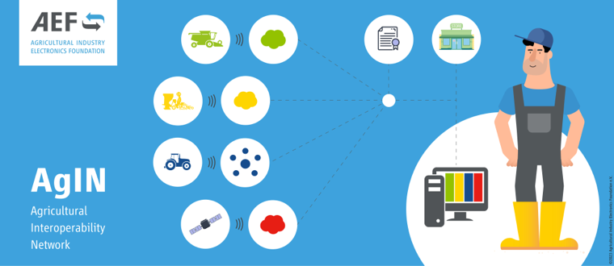

Caption: (Abb2.png)

Selected for the Systems & Components Trophy 2023

Caption (Abb3.png)
WIC increases road safety through direct vehicle-to-vehicle communication.
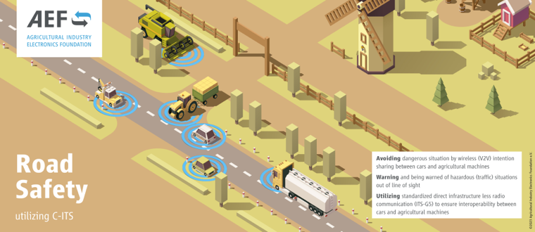

Caption: (Abb4.png)

Nominated for the Systems & Components Trophy 2023

Download press release:
https://www.aef-online.org/fileadmin/MEDIA/downloads/2023/AEF-PR-Agritechnica-2023.zip

AEF Media Contact:
Agricultural Industry Electronics Foundation e.V.
Frau Birgit Wagner
Mobile: +49 (0) 151 73 02 32 78
Email: birgit.wagner@aef-online.org
Web: http://www.aef-online.org

